**TechPros Limited**

SMART TECH SHOP

DELL LATITUDE 5410

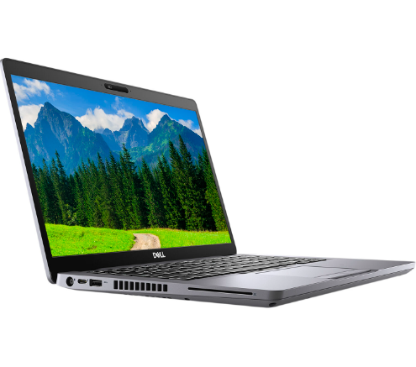

16GB RAM 10TH GEN

256GB HDD CORE I5